Report on analysis of two Dental Crowns for Mr Karl Nightingale

ACMA, Newcastle University, NE1 7RU.

Analysis done on the 1st December 2009

Introduction
Mr Nightingale brought two dental crowns in for elemental analysis by energy dispersive analysis by x-rays (EDX), one a partially metal coated ceramic and the other a solid alloy.

Results
Figure 1 shows the spectrum for the ceramic crown inner surface and the quantitative data from the analysis. The quantitative data is only approximate because the sample was not a smooth, flat, surface.

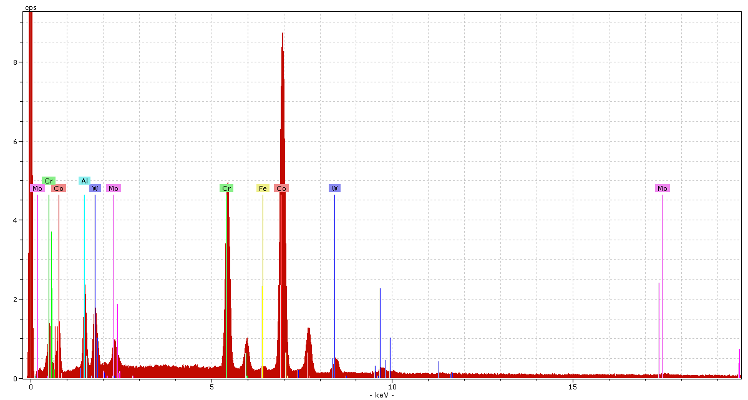
Figure 1 – EDX spectrum for the ceramic crown internal surface

Spectra: ceramic crown inner surface

Element norm. C Atom. C
[wt.-%] [at.-%]
------------------------------
Cobalt 57.4 56.5
Chromium 21.0 23.5
Tungsten 11.1 3.5
Aluminium 6.3 13.6
Molybdenum 3.3 2.0
Iron 0.9 0.9

The data show that the alloy coating used is a cobalt alloy containing chromium, tungsten and some aluminium, although some of the latter may be related to the sample holder which is also made of aluminium alloy.

Figure 2 shows the spectrum for the alloy crown and the quantitative data is shown below for the both the inner and outer surfaces. Again the surfaces are not flat and so the percentage values are just a guide.

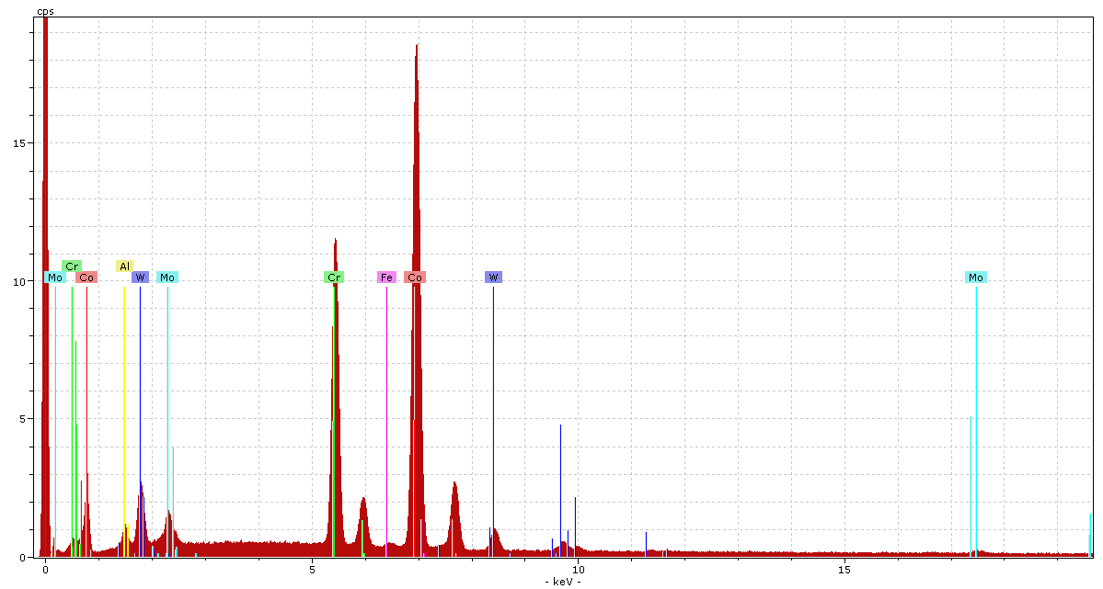
Figure 2 – EDX spectrum for the alloy crown

Spectra: alloy crown outer surface

Element norm. C Atom. C
[wt.-%] [at.-%]
------------------------------
Cobalt 56.7 60.5
Chromium 24.0 29.0
Tungsten 13.0 4.4
Aluminium 0.9 2.0
Molybdenum 4.4 2.9
Iron 1.0 1.2
------------------------------

Spectra: alloy crown inner surface

Element norm. C Atom. C
[wt.-%] [at.-%]
------------------------------
Cobalt 52.3 50.1
Chromium 23.2 25.2
Tungsten 11.1 3.4
Aluminium 8.7 18.1
Molybdenum 3.9 2.3
Iron 0.9 1.0
------------------------------

The data indicate that the inner and outer surfaces are similar in composition and that the alloy is cobalt based with a high chromium content and some tungsten and aluminium also present.

Discussion
The coating used on the ceramic crown and the alloy composition on the solid alloy crown appear to be similar and as chromium rich cobalt alloys these appear to relate closely to literature data for dental crown material.

Dr E A Charles, FICorr, CChem, MRSC, FRMS
Director of Analytical Services

